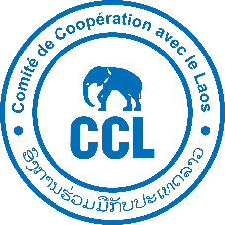
COMITÉ DE COOPÉRATION AVEC LE LAOS (CCL)
AGIRE / WaterWise Project — Nam Sa basin, Bolikhamxay Province, Lao PDR
Paksan provincial office — Bolikhamxay Province, Lao PDR
Our reference: AGIRE/TRV/2026/01X
Vientiane, 28th August 2026
Subject: Invitation to tender — Geophysical investigation and construction of water supply boreholes,
AGIRE / WaterWise project, Paksan district, Bolikhamxay Province
Dear everyone,
The Comité de Coopération avec le Laos (CCL) is implementing the AGIRE / WaterWise project in the Nam Sa catchment, Bolikhamxay Province, under a Memorandum of Understanding signed with the Bolikhamxay Provincial Health Office. The project works in ten villages of Paksan and Pakkading districts to improve access to safe drinking water, strengthen local water governance and support the sustainable management of the catchment. It is financed by the French Development Agency (AFD), the City of Paris, Fondation Groupe EDF and the Rhin-Meuse Water Agency.



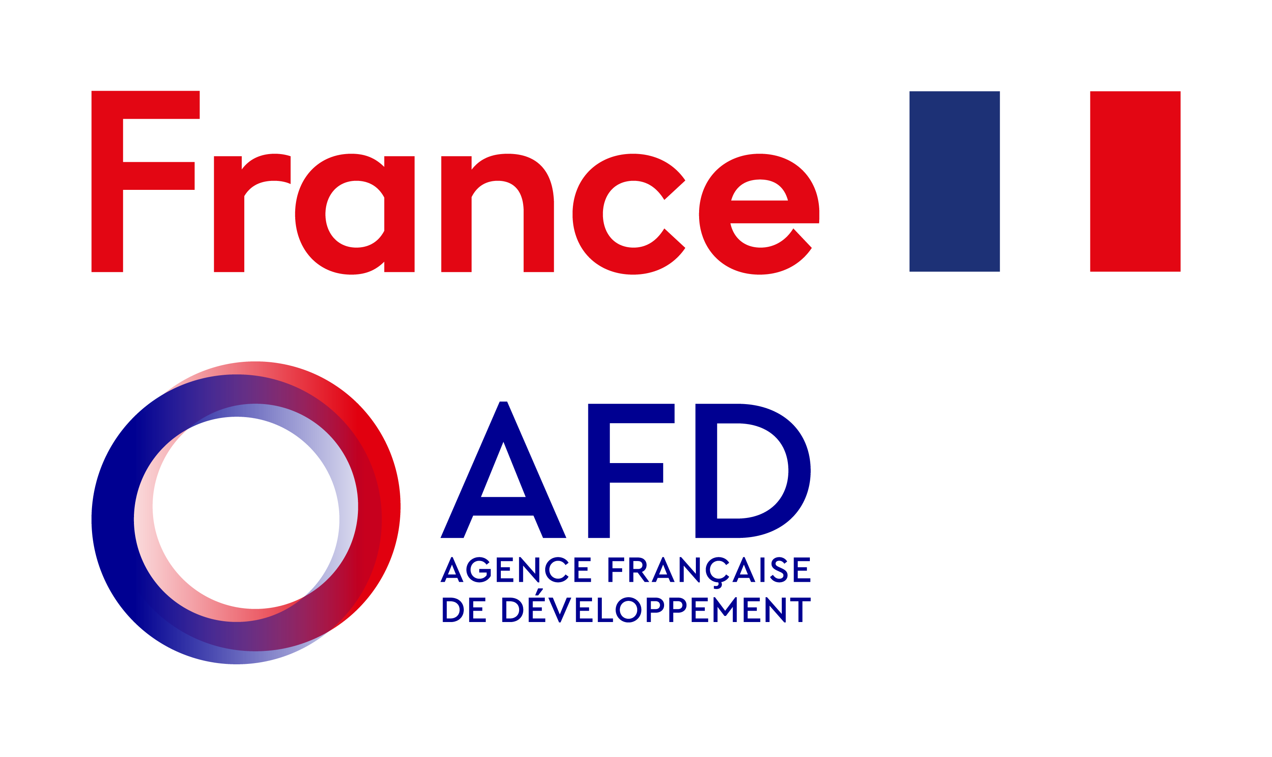

CCL invites companies to submit an offer for the works described in the technical specifications attached to this letter (reference AGIRE/TRV/2026/01X).
1. Scope of the assignment
The assignment is carried out in two stages by a single contractor, separated by a decision gate:
- Stage 1 (firm) — geophysical investigation and siting in three villages: desk review of the data supplied by CCL, electrical resistivity survey, targeting report proposing at least two ranked drilling targets per village, and joint site confirmation with the village committees. No site visit is required before the survey mobilization: CCL provides a detailed hydraulic study for each village.
- Decision gate. CCL reviews the targeting reports and decides, village by village, whether to proceed. Stage 2 is not committed at the time of award.
- Stage 2 (conditional tranche and option) — drilling works: one primary borehole per village as a conditional tranche, and one standby borehole per village as an option. A maximum of six boreholes is to be priced. Each borehole comprises drilling, casing and completion, sanitary annular grouting, development, step-drawdown and constant-rate pumping tests, wellhead securing and a full completion report including the lithological log and the hydrodynamic interpretation.
The three villages are as follows:
Village | District | Population | Coordinates (WGS 84)
Khamphai | Paksan | 632 inhabitants, 129 households | 18°29'57.3"N 103°48'35.0"E
Thongwarn | Paksan | 489 inhabitants, 111 households | 18°23'54.0"N 103°50'46.5"E
Nongsaman | Paksan | 514 inhabitants, 96  households | 18°22'32.7"N 103°50'35.8"E

Each borehole shall be designed to sustain a nominal duty of 10 m³/h at approximately 60 m total head (6 bar), using a 4" submersible pump. The pumps, electrical connections (solar and grid), reservoirs and distribution networks are procured and installed by CCL and are not part of this contract.
Your attention is drawn to article 6.6 of the specifications: since each drilling location is selected by the contractor on the basis of its own geophysical survey, an unproductive borehole is replaced at the contractor's own cost, within the limits set out in that article. This provision should be reflected in your pricing.
2. Content of the offer
Offers shall be presented in two separate parts, in accordance with article 14.1 of the specifications:
- a technical offer: administrative documents, drilling and geophysical references, description of plant (drilling rig, compressors, test pump, resistivity meter and inversion software), curricula vitae of key personnel, technical method statement, typical well design and anticipated schedule;
- a financial offer: the bill of quantities at Annex A of the specifications, completed, dated and signed, in Lao kip, inclusive of all taxes, with separate subtotals for Stage 1, for the three primary boreholes, for the three standby boreholes and for the optional items.
Offers may be submitted in English or in Lao.
3. Submission and deadline
Item | Details
Confirmation of intention to bid | By 11th September 2026, by e-mail to the contact below
Deadline for questions | 17th September 2026. Answers will be circulated to all invited companies
Deadline for offers | 18th September 2026, 17:00 Vientiane time
How to submit | By e-mail to erwin.poligne@ccl-laos.org, khammeun@ccl-laos.org, Manivone@ccl-laos.org, with "AGIRE/TRV/2026/01X" in the subject line, or by hand in two sealed envelopes marked "Technical offer" and "Financial offer" at the CCL office.
Validity of offers | 45 days from the closing date
Contact | Erwin Poligné, Project advisor, CCL — +856 20 52 62 81 74 — erwin.poligne@ccl-laos.org, Khammeun Nandee, Project coordinator, CCL — +856 20 29 253 654 — khammeun@ccl-laos.org, Manivone Vorachak, Director, CCL — +856 20 22 240 943 — Manivone@ccl-laos.org

Offers received after the deadline will not be considered.
4. Evaluation
Offers will be assessed against the criteria set out in article 14.2 of the specifications: 70 points for the technical offer and 30 points for the financial offer. Offers scoring less than 45 of the 70 technical points will be set aside before the financial offer is opened. CCL may visit your premises and contact your references.
CCL is not bound to accept the lowest or any offer, may cancel the consultation at any time without incurring liability, and gives no undertaking as to the number of boreholes that will be ordered.
We should be pleased to receive your offer and remain at your disposal for any clarification you may require.
Yours faithfully,
___________________________
Erwin Poligne,
Project Advisor, Comité de Coopération avec le Laos.
Enclosures:
1. Technical specifications AGIRE/TRV/2026/01X — English version
2. Annex A — Bill of quantities (to be completed and returned)

