Job Description
This form enables us to accurately post your position on external sites. The information provided here will be featured in the job post. Please do not use acronyms or industry jargon. Be clear and concise in your answers to the open-ended questions. Incomplete forms will delay posting. Once this form is complete, email it to the CARE Laos HR Unit.

Position Information
Position Title: Senior Project Officer | Date requested: Aug 2026
Type of position: Sr. Project Officer base in Lao Ngam District, Saravan Province | Grade (for HR use only):
Department/Project Team: She Grows The Future (SGTF) Project

WORK LOCATION: Salavan Province | Incumbent’s name (if applicable): N/A

Job Summary
In 1000 characters or less, state the position’s overall purpose or objective, highlighting the general functions the position is responsible for and articulating what the position is expected to accomplish. This section will appear on external sites.

The Senior Project Officer will lead activity implementing at the field target villages alongside with the project partners including Women Association for Development of Women and Legal Education (ADWLE) following the project proposal and partnership agreement identified in the proposal of the She Grows The Future (SGTF) Project in Salavan Province.
This position will work in partnership with the DHO, LWU, DAFO, DONRE and in close coordination with other CARE development projects in Salavan Province, Lao PDR.
This position will support the coordination and implementation of the project by providing technical advice to the ADWLE and project partners and implementing key aspects of CARE’s work on promoting and supporting women agents of change by strengthening their capacity to acts, adapt and conserve actions on their own initiative and in their favor, but also by enabling women-led civil society to structure itself and influence legislative processes at various levels.
The program's ambition is to take a transformative approach to women and girls’ norms, making awareness-raising among different players, and men particularly, a key focus of action.
This position is based in Salavan Province with extensively travel to project target villages in Lao Ngarm District.

Responsibilities and Tasks
Describe the major responsibilities, principal tasks, and end results the position is responsible for. Please include rationale as to why it is done and the impact it has on the team or organization. List the responsibilities in the order of importance and state the estimated percentage of time the employee should spend on each responsibility during a typical year.
10% of time

JOB RESPONSIBILITY 1: STRATEGY AND LEADERSHIP
- Actively contribute to CARE Laos strategic direction setting and organisational development as a member of CARE Laos;
- In cooperation with senior managers promote organisational cohesion and learning organisation through coordination and information sharing with and between all staff; and
- Demonstrate a passion and commitment to CARE’s approach and values including women and girls’ equality, ethnic diversity and cultural sensitivity and inspire leadership on these issues through the CARE Laos team.

JOB RESPONSIBILITY 2: Project Implementation AND QUALITY ASSURANCE
50% of time

- With the support from the Provincial Manager, responsible of planning, implementing and monitoring activities and reporting of project activities;
- Develop an annual and monthly work plan and Cost of Work Plan for project ensuring that work plan and activities implementation is in line with the project Log frame and program/project objectives;
- Responsible to prepare the accurate activity report in a timely manner to the Provincial Manager (including Annual, quarterly and monthly reports) as well as provide oral and written reports on progress of the activities – as contribution to internal and external reports– if it is requested;
- Keep regularly informed Provincial Manager on the activities, problems faced during the implementations and share accurate information and updating during weekly/monthly meeting and other relevant meeting;
- Lead in organizing monthly and IMC project meeting together with the Provincial Manager and government counterparts;
- Ensure that data records, documents/forms used in soft copy and hard copies are filled properly and timely by the team;
- Liaise with Admin, Finance, and Logistics staff for organising and planning of assistance delivery following the procurement requirements;
- Assist and provide support the team and government counterpart in delivering the training;
- Implement activities such as arranging and facilitating community meetings and participate in trainings;
- Organise and facilitate community meetings in agreement with village head and village residents and other participants;
- Support the project in the facilitation of activities including data collection, monitoring and implementation of project activities.
- Ensure the efficient and proper use of project funds in line with the approved budget and in compliance with CARE’s finance manual and donor guidelines.
- Utilise budget according to CARE authorization policy, request and clear all field cash advances in a timely fashion in accordance with CARE Finance policies and procedures and ensure manage any cash advances in line with financial management
15% of time

JOB RESPONSIBILITY 3: Monitoring Evaluation and Learning:
- Be the project focal point for Monitoring, Impact, Learning, knowledge management and accountability (MILKA) implementation at the field level;
- Entering data into the Activity Tracking System following the advice from the MILKA team;
- Actively implement agreed technical approaches and provide feedback on these and contribute to regular monitoring:
- Women and girls’ equality:
    - Understand key women and girls’ equality concepts and CARE approaches;
    - Ability to facilitate action and reflection at community level to empower women and reflect on
- Climate Change: Understand key impacts of Women and girls Sensitive Community Vulnerable and Capacity Assessment (GCVCA) at community level and support community to analyze these and take action, support implementation of climate adaptation techniques, support generation of knowledge on CC adaptation planning at community level, support women’s voice in adaptation planning
10% of time

JOB RESPONSIBILITY 4: caPACITY BUILDING AND COORDINATION
- Support line manager to conduct asset physical checks and update asset lists in Vientiane Office including collaborating with relevant offices to ensure the asset lists are updated every 6 months;
- Support line manager of any hand over letter/ asset disposal process.

JOB RESPONSIBILITY 5: PARTNERSHIP AND NETWORKING
10% of time

- Work closely with the ADWLE and provide necessary support to them to ensure that project is implemented following the project plan;
- Work closely with the CARE Partnership Coordinator to ensure that any necessary partnership requirements are up to date including project workplan, report, contract, capacity building, etc.;
- Provide clear explanations of CARE Laos program strategy and CARE’s work in Laos to internal and external stakeholders; and
- Develop and maintain effective relationships with relevant internal and external stakeholders
5% of time

* OTHER RESPONSIBILITIES AS ASSIGNED
- Proactively participate or manage in the Annual Planning and Performance Appraisal (APPA) process including the annual appraisal, midyear review and regular 1:1 meetings, ensuring that the APPA process (including the paperwork) is an integral component of Annual Work Plans and activities;
- Demonstrate an ongoing commitment to women and girls’ equality, diversity and commitment to the safeguarding policy on Protection from Sexual Harassment, Exploitation and Abuse (PSHEA) and child protection;
- Comply with CARE Lao’s financial and operational requirements, foster strong communication between operations and program teams and uphold high standards of honesty and integrity in personal conduct.

Qualifications (Know How)
Indicate the minimum required level of education, experience, and skills necessary to qualify for the position and fulfill the organization’s expectations for job performance. Also include the education, experience, and skills desired for the position.

Education/Training
E.g. high school diploma; college degree (specify major/minor); specialty (ex. Accounting). Include the following phrase when possible: “or equivalent combination of education and work experience.”

Required
EXPERIENCE AND QUALIFICATIONS:
- Minimum Bachelor Degree in international development, climate change, agriculture, ecosystem, natural resource and environment, rural development, climate change or related field or equivalent;
- Minimum 5 years relevant work experience in women and girls’ engagement, economic empowerment, preferably with an International Non-Government Organisation (INGO) and/or community language abilities;
- Strong experience in Project Management and working with the NPAs;
- Proven experience in women and girls’ sensitive DRR/M and CCA approaches tools;
- Knowledge on household food security;
- Demonstrated experience in following standard policies, procedures and processes and ensure the implementation of basic standard transactions including the management and acquittal of a cash advance.
- A willingness to learn about CARE, women and girls’ equality and women’s empowerment activities;

Desired

Experience/Technical Skills
Number of months/ years of previous professional experience in a similar position. Examples: languages; planning; budgeting; basic accounting; presentations; fundraising; training/facilitation, etc.

Required
- Good communication in English skill.
- Demonstrated good interpersonal skills, sound judgment, planning, problem solving and team building skills;
- Ability to work as a team member and contribute his/her capabilities to group objectives and works effectively in a group setting;
- Demonstrated organisational and time management skills, working in a team and the ability to work under pressure and to organise and manage workload to meet deadlines;
- Demonstrated characteristics in honesty, reliability, trustworthiness with the ability to maintain confidentiality;
- Fluent oral and written communication skills in Lao and intermediate oral and written English; and
- Intermediate (very good) ability in Microsoft Word, Excel and numeric skills.

Desired

Problem Solving
Click on each level (1, 2 or 3) below to indicate what level of problem-solving this position will face.

Select Level:
1. What has to be done and how to do it are clearly defined, and the incumbent with face identical or similar problem on a regular basis

2. What has to be done is known, but how to do it is not defined. The incumbent must use interpolative skills to pick and choose the right strategy to address a given problem.

3. Why things are done is known, but what has to be done and how to do it is not defined. : Situation are variable and the incumbent’s response will involve analysis, problem definition, development of alternatives, and making recommendations. He or she will face and address problems that are typically non-recurring.

Why does the position fall into this category?
This position is Senior Project Officer, must be respond for project planning, implementing the plan, monitoring and evaluating including coordination with public sector partners and associations.

Competencies
CARE has 5 Core Competencies that all staff are expected to demonstrate and 2 Leaders Competencies expected of those in management and leadership positions.

Competency proficiency levels define the degree to which a person in a given job is required to demonstrate the competency through observable behavior.

The chart below provides guidance when assigning proficiency levels to jobs. This guidance should be used as a starting point.

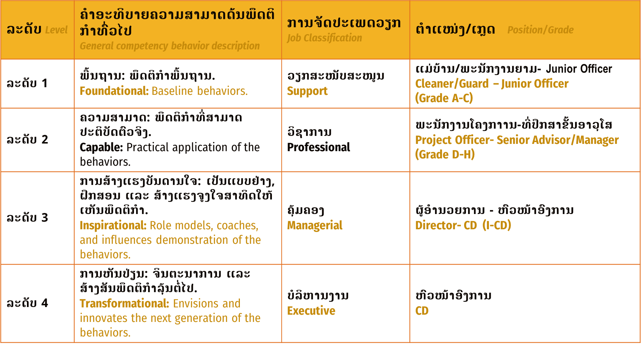

A. Core Competencies
Please indicate at what proficiency level you expect this role to demonstrate each Core Competency. This may be used in performance conversations and as a guide for staff development.
- RELATIONSHIP BUILDING : 2. Capable
Develops internal and external trusting & professional relationships. Purposefully develops networks to build value through collaboration.
- INCLUSION 2. Capable
Contributes to an environment where all employees feel a sense of belonging, valued for their differences, and empowered to participate and contribute freely.

- DYNAMIC LEARNING MINDSET 2. Capable
Continuously seeks opportunities to learn, questions past approaches in the current environment, owns growth and learns from failure.

- DELIVERING RESULTS 2. Capable
Invests time in planning to achieve goals while meeting quality standards & demonstrating commitment.

- COMMUNICATION 2. Capable
Effectively and appropriately interacts with others to build relationships, influence, and share ideas. Uses tact, diplomacy & cross-cultural sensitivity to navigate difficult situations.

B. Leadership Competencies
If this role is expected to manage direct reports, please indicate at what proficiency level you expect this role to demonstrate each Leadership Competency. This may be used in performance conversations and as a guide for staff development.
- Strategic Leadership & Execution 1. N/A
Applies vision to think beyond the immediate situation. Invests time in planning, discovery, and reflection. Ensures business goals are met by executing, monitoring, & adjusting.

- PEOPLE LEADERSHIP 2. Capable
Inspires, motivates, & empowers people to achieve organizational goals. Coaches, mentors, and manages employee experience, and employee performance. Creates space for others to lead.

C. Functional Competencies
Choose the top 3 Functional Competencies that this role must demonstrate to create the desired impact. There are many competencies that will fit the role, however, please think about the most essential skills needed for this position to succeed in their role. This may be used in performance conversations and as a guide for staff development.

Competencies | Proficiency Level
1. Ability to influence staff to understand the procurement policy and follow the donor rule & regulation. | 2. Capable
2. Effective communication with internal staff & partners together with the government counterpart. | 2. Capable
3. Continuously seeks opportunities to learn the new thing, owns growth and learns from failure. | 2. Capable

Organization Structure

