June 2026

Making progress to end avoidable blindness in Lao PDR

International development organisation The Fred Hollows Foundation is making strong progress to end avoidable blindness in Lao PDR with more than 5,800 people receiving eye operations and treatments last year.

The Foundation’s Lao PDR Senior Program Manager Phonethip Vorachith said efforts to increase people’s access to eye health, particularly in rural communities, was a major priority.

“Cataract is the leading cause of blindness in our country and women are disproportionately impacted, accounting for more than 60 percent of people who are blind.

“We can restore sight with simple interventions, but we need more investment to realise the gains we are making,” he said.

Mr Phonethip said investing in eye health was a key step forward in fostering economic development and ensuring more children stay at school and go on to contribute to the economy and their communities.

Research from The Foundation, the IAPB and Seva Foundation show that a USD$2.12 million investment in simple, cost-effective eye health initiatives in Lao PDR could unlock USD$31.2 million in economic benefits each year.

“The Value of Vision research shows that eye health is one of the best possible investments for Lao PDR and with more resources, The Foundation and its partners are well-placed to make further inroads to end avoidable blindness,” he said.

The Global Results were released at The Foundation’s Annual General meeting in Sydney, Australia.

Lao PDR Global Results 2025

- 44,604 people screened
- 5,811 eye operations and treatments
- 7,943 pairs of glasses distributed
- 3,056 people trained (including community health workers, teachers, clinic support staff and surgeons)

Media contact:

Reynald Ramirez
Global Communications Advisor | The Fred Hollows Foundation
Mobile: +63 917 626 1216
Email: rramirez@hollows.org

CASE STUDY

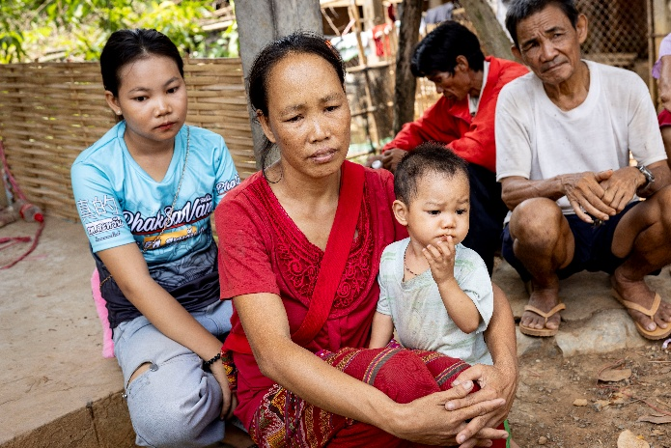
Photo: Michael Amendolia
“It’s like a new life for me” – new hope for Lien

For the past three years, Lien has felt angry and depressed. Blindness has left her unable to work or recognise people’s faces.

The 38-year-old mother-of-two from Oudomxay province in Laos says she has lost confidence as a mother.

Lien is particularly worried about the safety of her son Bountai who is almost two. The family live just 20 steps away from a busy highway where trucks regularly roll past at speed.

“It’s difficult. Sometimes I’m looking for him inside and outside and he’s right here.”

“When he strays near the road, the neighbour shouts at me.

The family can’t afford the medical help Lien needs, let alone the transport costs to access eye health services.

With the family struggling to make ends meet, Lien’s 14-year-old daughter Aomphai left school this year and is working at a banana plantation from 6am to 7pm four days a week.

“I feel frustrated. I want to do things for my children but I cannot do it. I am depressed, angry. I want the best for myself and my family but I cannot do the best for them.

“If my eyesight is good, I want my daughter to go back to school,” she said.

When Aomphai finishes work, she has to cook and look after her younger brother.

“I want to help my family because we are poor. I pity my Mum because it’s so difficult and I must help her. Our family is poor. I need help.

“I am excited for my mum's surgery because I want to see my mother go back to what she was before,” Aomphai said.

The Fred Hollows Foundation, with the support of the Australian NGO Cooperation Program (ANCP), is reaching people like Lien who cannot afford cataract surgery in Oudomxay.

Most people in Lao PDR are entitled to access health insurance but people living in remote areas, ethnic minority groups and women – are less likely to enrol.

In Lao PDR, women account for up to twice as many cases of blindness as men.

The Foundation’s Strengthening Eye Health System program is removing barriers faced by women and marginalised community members living in seven provinces and supporting the National Health Insurance Bureau to strengthen access to its insurance schemes.

Through the program, Lien attended an outreach eye camp and met Dr Senglar Laosern, who was trained by The Fred Hollows Foundation.

Lien, husband Orathai and Bountai travel to Oudomxay Eye Hospital where Dr Senglar performed cataract surgery on both of her eyes.

The next day when the patches are removed, Lien is crying – she can see Bountai clearly for the first time. Her sight is so good she can see a small mosquito bite on Bountai’s forehead.

Lien also calls Aomphai to tell her she can return to school.

“I said: ‘Mum has completed her surgery’ – and she said: ‘Oh, my mum will be able to see me’.”

“I can help my husband earn more money and I will be able to take my daughter to school. It’s like a new life for me,” she said.

