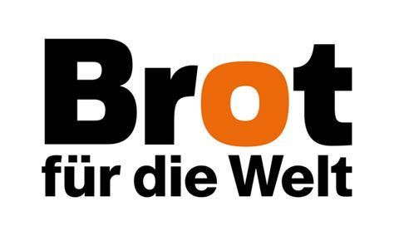
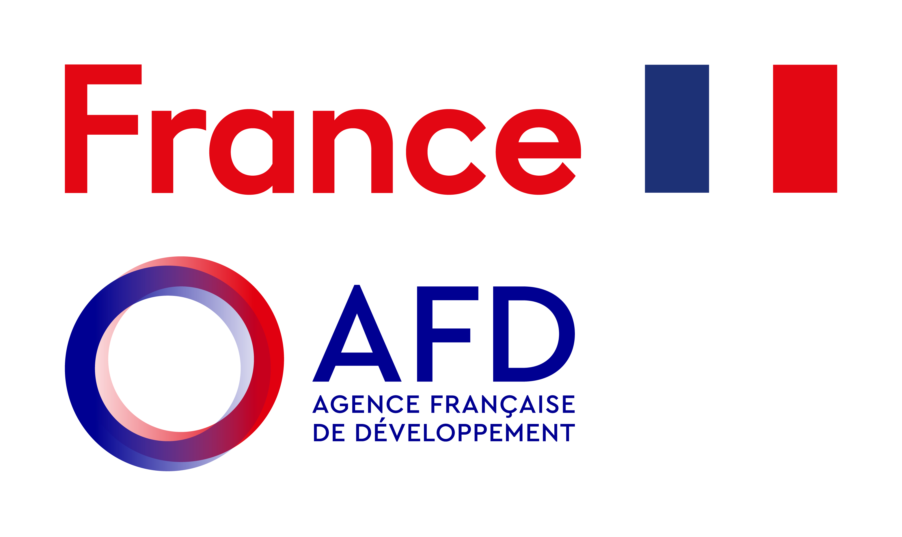
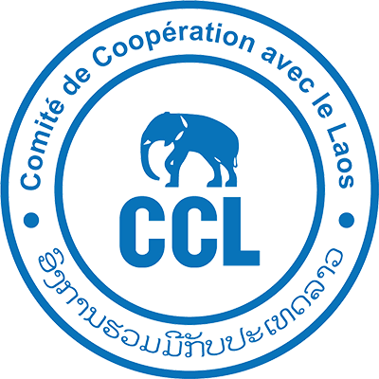

Comité de Coopération avec le Laos (CCL)
ASEAN Road, House n° 123, Unit 7
Sidamdouane Village, Chanthabouly District
BP 4791, Vientiane, Lao PDR
+ 856 21 25 40 39 / robert.williamson@ccl-laos.org / erwin.poligne@ccl-laos.org
Date: 28-05-2026
Subject: Invitation to Tender for the Supply of Water Supply Materials for Noy village, Phongsaly Province, Boun Neua district.
Reference: PSY-GR-005
Dear Sir/Madam,
CCL is pleased to invite your company to submit a tender for the Supply of Materials for a water supply system under the project Generating inclusive Resilience and Environment Enhancement (GREEN) in the village of Noy (https://maps.app.goo.gl/jMZd4WSPh4rBjw83A), Boun Neua District, Phongsaly Province.
This tender concerns the supply and delivery of all civil works and piping materials as detailed in the enclosed Bill of Quantities (BoQ). The project aims to provide a sustainable and clean water source to the communities, and the quality of materials is of prior importance.
The complete tender file includes the following documents:
- Cover Letter (this document)
- Administrative Regulation & Draft Contract
- Bill of Quantities (BoQ) and GSP Pipe Cutting List
- Material Technical Specification (Detailing required quality standards)

Bidders are required to submit their offers in a sealed envelope, clearly marked with the tender reference, to the address below no later than Monday 22nd June 2026 at 10:00 am Vientiane Time.
Offers will be evaluated based on a combination of technical compliance (quality of proposed materials, adherence to specifications) and economic factors.
For any technical clarifications, please contact:
Name: Erwin POLIGNE
Position: Technical Advisor
Email: erwin.poligne@ccl-laos.org
Phone: +856 20 52 62 81 74
Name: Robert WILLIAMSON
Position: Project Advisor
Email: robert.williamson@ccl-laos.org
Phone: +856 20 92 02 41 92
Name: Pasert KOUNSOMHUENG
Position: Project Coordinator
Email: sertk14@gmail.com
Phone: +856 20 95 530 140
Submission of tender:
Bidders are required to submit their offers either by email or in a sealed physical envelope. The deadline for submission is immutable.
1. Submission by Email:
- Email Address: robert.williamson@ccl-laos.org ; sertk14@gmail.com ; erwin.poligne@ccl-laos.org ; manivone@ccl-laos.org
- Format: The complete tender must be submitted as a single PDF file. The PDF file must be protected and set to open on Tuesday, June 23rd at 10:00 am. All forms (BoQ, etc.) must be fully completed, and the PDF must include a scanned copy of the signed "Bid Submission Sheet" (or the cover page of your tender dossier).
- File Size: Ensure the file is not too large. If necessary, you can send multiple emails stating "Email 1 of 2", etc.
- Confirmation: Manual confirmation of receipt will be sent within 24 working hours. It is the bidder's responsibility to ensure their offer has been received before the deadline.
2. Submission by Physical Courrier / In Person (Preferred method):
- Address: CCL headquarter, ASEAN road, House n’123, Unit 7 – Sidamdouane village – Chanthabouly District – BP 4791, Vientiane capital.
Deadline: The sealed envelope must be received at the address above no later than Monday 22nd June 2026 at 10:00 am Vientiane Time.
- Envelope Marking: The outer envelope must be clearly marked with:
  - "TENDER FOR WATER SUPPLY MATERIALS - PSY-GR-005"
  - "DO NOT OPEN BEFORE Tuesday 23rd June 2026 at 10:00 am
  - The name and return address of the bidder.
We look forward to receiving your competitive bid.
Sincerely,


Name: Manivone VORACHAK Seal and signature:
Title: CCL Director
Date: 28-05-2026

-- LATE SUBMISSIONS WILL BE AUTOMATICALLY REJECTED--

