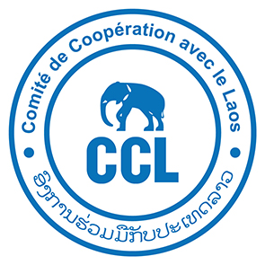

**Comité de Coopération avec le Laos (CCL)**is a non-governmental organisation working in Lao PDR  
for more than 30 years in rural development.

CCL is seeking a highly skilled and motivated Lao national for the position of

**Deputy Team Leader**

**Agribusiness Specialist**Vientiane & Khammouane Province

**Qualifications and experience:**

* At least a **master’s degree in agriculture, Soils Sciences or equivalent**.
* A minimum of **ten years of relevant work experience** and at least three **rural development projects;**
* Demonstrated strong experience in innovative cropping systems, engineering/design and implementation;
* **Familiar with Agro-ecology concept and practices**, notably Conservation Agriculture, and “tools” for the development of local actors’ capacities;
* **Experience in irrigated agriculture;**
* Be familiar with participatory land use planning and participatory approaches;
* **Proficiency/fluency in written and spoken English.**

**Main responsibilities:**

**Support to Team Leadership**

* Assist the Team Leader in overall project planning, execution, monitoring, and reporting.
* Provide input to strategic decision-making, risk management, and stakeholder engagement.

**Project Coordination and Implementation**

* Coordinate day-to-day implementation of project activities at the field level.
* Ensure alignment of activities with project goals, timelines, and budgets.
* Supervise field teams and provide technical guidance to technical assistants (irrigation, agriculture, value chains).
* Facilitate community mobilization and participation in project planning and implementation.
* Address stakeholder concerns and ensure community needs are reflected in project outputs.

**Monitoring, Evaluation, and Reporting**

* Support the development and application of monitoring and evaluation (M&E) tools.
* Ensure regular data collection and reporting on project progress, challenges, and outcomes.
* Contribute to preparation of reports (monthly, quarterly, annual) for donors and government agencies.

**Capacity Building and Training**

* Organize and oversee training and capacity-building activities for project staff, local partners, and communities.
* Identify training needs and ensure delivery of context-specific, practical training modules.

**Budgeting and Resource Management**

* Support the Team Leader and finances officer in budget planning, financial tracking, and ensuring efficient use of project funds.
* Monitor procurement and logistics to ensure timely delivery of resources.

**Quality Assurance and Compliance**

* Ensure compliance with donor and government regulations, including environmental and social safeguards along with environment and social specialists

Please send your expression of interest and CV to Mr Anthony Gueguen: [a.gueguen.ccl@gmail.com](mailto:a.gueguen.ccl@gmail.com) and Ms Violaine Fourile: violaine.fourile@ccl-laos.org