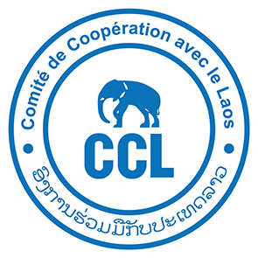

Comité de Coopération avec le Laos (CCL)
is a non-governmental organisation working in Lao PDR
for more than 30 years in rural development.
CCL is seeking a highly skilled and motivated Lao national for the position of
Agriculture and Irrigation Specialist
based in Khammouane Province

Qualifications and experience:
- At least a bachelor’s degree in agriculture
- A minimum of ten years of relevant work experience and at least three rural development projects as project director/coordinator;
- Demonstrated hands-on experience in a range of cropping systems;
- Familiar with Agro-ecology concept and practices, notably Conservation Agriculture, and “tools” for the development of local actor capacities;
- Experience in irrigated agriculture and setting up of small-scale irrigation systems;
- Experience with groundwater use for agriculture a strong plus.
- Experience in working with water user organization is desirable;
- Familiar with participatory land use planning and participatory approaches;
- Proficiency/fluency in written and spoken English.

Main responsibilities:

Provide technical support on data and information management to the team:
- Survey design, data collection, and implementation of performance monitoring systems and tools;

Monitoring and Evaluation:
- Ensure that the quality of the project is maintained through an effective monitoring system and that accurate data and information on best practices is documented.

Project Management:
- Support the development of annual project workplans and monthly activity report;
- Co-build provisional budgets, ensure project budget monitoring, compliance with administrative procedures, in support of the project administrative and financial manager,
- Communication with local authorities and representatives of the various services involved in the project: negotiation, planning and reporting;
- Promote shared learning and collaboration between partners by facilitating partner networks and meetings;

Capacity building
- Participate in the development, monitoring and capitalization of skills-building training plans for staff, partners and beneficiaries.

Please send your expression of interest and CV to Mr Anthony Gueguen: a.gueguen.ccl@gmail.com and Ms Violaine Fourile: violaine.fourile@ccl-laos.org by the 23th May 2025

