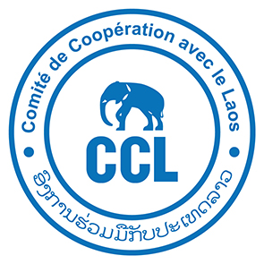

**Comité de Coopération avec le Laos (CCL)**is a non-governmental organisation working in Lao PDR  
for more than 30 years in rural development.

CCL is seeking a highly skilled and motivated Lao national for the position of

**Design and Construction Supervision Engineer**Vientiane & Khammouane Province

**Qualifications and experience:**

* At least a **bachelor’s degree** in civil or agricultural engineering with irrigation and hydrology as majors or as post graduate studies, or equivalent.
* At least **12 years’ experience in design and/or implementation of irrigation infrastructure projects** involving gravity and pumped irrigation systems (minimum 7 years);
* **Experience in construction projects**, of which at least three (3) must be as a member of the construction supervision team in internationally funded infrastructure projects.
* At least six (6) years of experience in a developing country, with Lao PDR or another southeast Asian country preferred.

**Main responsibilities:**

**Provide technical support on construction design**

* Leading design, implementation and follow-up of irrigation systems based on the principle of Decentralized Irrigation Schemes (DIS)
* Leading management and design of operation and maintenance of Solar Irrigation Pumping (SIP).

**Project Management:**

* Support the development of annual project workplans and monthly activity report;
* Co-build provisional budgets, ensure project budget monitoring, compliance with administrative procedures, in support of the project administrative and financial manager,
* Communication with local authorities and representatives of the various services involved in the project: negotiation, planning and reporting;
* Promote shared learning and collaboration between partners by facilitating partner networks and meetings;
* Strong communication with team leader and deputy team leader of the project

**Capacity building**

* Participate in the development, monitoring and capitalization of skills-building training plans for staff, partners and beneficiaries.

Please send your expression of interest and CV to Mr Anthony Gueguen: [a.gueguen.ccl@gmail.com](mailto:a.gueguen.ccl@gmail.com) and Ms Violaine Fourile: [violaine.fourile@ccl-laos.org](mailto:violaine.fourile@ccl-laos.org) by the 23th May 2025