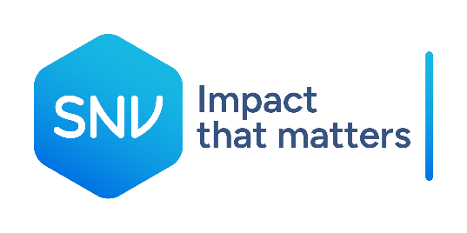
Terms of Reference
Finance Consultant (National only)

About SNV
SNV is a mission-driven global development partner, rooted in the contexts and societies where we work. Inspired by the transformational principles and objectives set out by the SDGs, we are committed to building resilient agri-food systems that deliver food security and adequate nutrition; to increasing the reliability and availability of water and sanitation at an acceptable quantity and quality; and to improving access to affordable and sustainable energy for all.

In doing so, we aim to strengthen institutions, markets and effective governance within and across the Agri-food, Energy, and Water sectors, reduce gender inequalities and barriers to social inclusion, and enable adaptation and mitigation to the climate and biodiversity crises.

We are one team of over 1,600 people, the vast majority of whom come from the contexts where we work, in more than 20 countries in Africa and Asia. Together, we are committed to effective and efficient stewardship of resources and maximising positive, lasting impacts. Our ability to deliver results rests on our robust foundation of experience, knowledge, evidence and learning; our commitment to strengthening capacities and catalysing partnerships; and the relationships and trust of those we work alongside.

In SNV’s strategic framework (2023 – 2030) our focus is on contributing to a transformational level of change in agri-food, energy, and water systems - resulting in sustainable and more equitable lives for all. In all our work, the wider goal of transforming systems is embedded in the choices we make, inclusive of the enabling, facilitative, and partnership-centric approaches we take within our projects and programmes.

For more information on SNV, visit our website: www.snv.org.

Purpose of the job
SNV, in partnership with WFP, is implementing a nutrition project under component 4 of the Sustainable Rural Infrastructure and Watershed Management Sector Project (SRIWMSP). The project aims to improve household nutrition through the production of nutrient-dense crops at the household level. To achieve this, the project is responsible for developing local government staff capacity and providing on-the-job coaching to ensure they can deliver high-quality activities and complete them within the project timeline. The project is hiring a finance consultant who will take a role in backstopping and closely supporting the Finance department of the Provincial Agriculture and Forestry Office (PAFO). The consultant will also provide on-the-job coaching to the District Agriculture and Forestry Office (DAFO) and the District Lao Woman Union (DLWU) staff on budget request and clearance.

Key responsibilities
The Finance Consultant will undertake the following tasks:

Close consultation between the Finance person
- Assist the PAFO finance staff to manage and summarize program expenditures for district activities.
- Assist the PAFO finance department to process payments to the district's nutrition team (DNTs).

- Follow-up of documents from three districts
- Travel to the three districts to support DAFO staff to clear their budget upon activity completion.
- Engage in monthly planning meetings with SNV Field staff to finalize the activities and budget plan for the following month and ensure the budget requests are aligned with finance policy and are submitted on time.
- Other tasks as required by the line manager(s).

Qualifications
The preferred consultant should have the following qualifications, experience and competencies:
- Graduated with a degree(s) in Business, Finance, Banking, or Accounting.
- At least two years experience in a similar field.
- Intermediate level of English.
- Fluency in both oral and written communication in Lao

Additional Information

Contract Type and Duration: 9 Months

Contract Type: Service Contract

Duty station: Huaphanh Provincial Agriculture and Forestry Office (PAFO) with frequent travel to districts ( Sopbao, Viengxay and Samnuar)

Desired Start Date: 1st June, 2025

Key Steps in the Selection Process
- If you believe that your credentials meet the outlined profile, we invite you to apply by uploading your CV (not more than three pages with three referees) and motivation letter (not more than 1 page) by clicking on the "I'm interested" button on, SmartRecruiter https://smrtr.io/q-d2Y before 4th May 2025
- We will require you to provide us with the details of three people willing to act as referees. We will not contact these referees without your explicit permission. Please note that reference checks may be conducted before the selection decision.
- Should SNV wish to proceed with your application, two interviews with the Selection Committee will occur.
- After your interviews with the Selection Committee, we will advise you of the Committee's decision as soon as possible.

ONLY SHORTLISTED CANDIDATES WILL BE CONTACTED.

