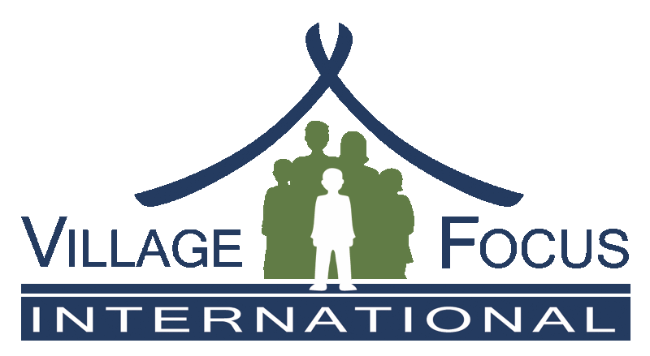

VFI is recruiting for the position LIFE Project Manager, Phase IV
Lao National or Expatriate

Location: Based in Vientiane Capital, with some travel to the field (country-wide).
Position: Full time position as LIFE Project Manager, for Phase IV of the project.
Time Period: Annual contract: Jan 2025 – Dec 31, 2025, with potential initial funding available until Dec 31, 2027.
Language: English required, and high-level Lao Language ideal.

Detailed TOR Available Upon Request

Summary of TOR
LIFE is a key capacity building project on land and NRM law in Laos, aiming to contribute to smallholder family farmers, especially women and those from ethnic groups, to ensure equitable land tenure through enhanced capacity of key stakeholders (officials, CSOs, DPs, and villages), and to promote and protect tenure rights. LIFE supports practical experiences of law students in NRM and environmental law with the goal to interest more future lawyers for this field.

The LIFE Project Manager (PM) is responsible for overall project planning, implementation, reporting, financial management, staff supervision, M&E, etc. The PM works in close collaboration with the team leader (TL), the VFI L&L Coordinator, and the VFI Executive Director.

Main Responsibilities:
- Project/Finance/Staff management;
- Fund-raising;
- Liaison with the LIFE Advisory Committee;
- Representation and partner liaison, including with the GoL;
- Monitoring and evaluation; and
- Other tasks as they arise, as defined by VFI and the LIFE Steering Committee.

Knowledge, Skills, and Attitudes:
- Demonstrated capacity to manage large/complex development projects (minimum 5 years’ experience);
- Long term project planning and risk management;
- Communication and relationship building with a wide ranging of stakeholders;
- Report writing;
- Managing staff, including mediation and relationship building;
- Spoken/written English and ideally also Lao language; and
- Using standard office programs.

The position also requires: Commitment to land rights for local people • Ability to communicate effectively, work as a team • Experience in and appreciation of ethnic minority groups and gender-related issues • Willingness to travel and work in provinces as necessary • Fluency in written and spoken English and (ideally) Lao • Ability to develop program reports in English and capacity to work directly with LIFE project donors.

Please send a letter of interest and CV to VFI by December 20, 2024, indicating ‘LIFE PM Position’
Tel: 021- 312519 (attn. Mr. Athithane) or email to a.mahathirash@villagefocus.org

