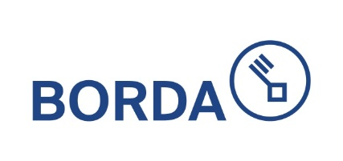**BORDA Laos is looking for a**

Administrative Intern

BORDA is a German NGO with operations in more than 15 countries worldwide. BORDA has been active in Laos since 2013 – with the aim to improve the living conditions of disadvantaged communities and to keep the environment intact through the expansion of sanitation services in the areas of decentralized sanitation, faecal sludge, solid waste management and holistic livable city planning. We work with local governments and enterprises to improve communal planning processes, sanitary supply structures and services in cities at variety of scales and applications. *see also https://www.borda.org/*



**Job Summary**

BORDA Laos is seeking an Administrative Intern

The objective of this internship is to provide the intern with hands-on experience in administrative tasks within BORDA Laos, while supporting the organization's overall operations

BORDA Laos is currently seeking a Lao national to fill the following position:

Full Time Administrative Intern 01.10.2024-31.12.2024 ( 2025 will renewal contract)

Location: Vientiane, Laos

**Responsibilities the Administrative Intern will be responsible for the following tasks:**

* Assist in maintaining and organizing administrative records, including filing, archiving, scanning and document management.
* Assist on label sign to inventory, ensuring availability of necessary resources
* Support the finance team in basic vouchers preparation and assist finance for prepare financial document to auditor.
* Assist on office payment as member ship, NSSF and etc.
* Assist on research in relevant administrative topics as assigned
* Provide general administrative support to different teams as requires
* Assist on arrangements and submit travel for staff members
* Another task assigned by supervisor.

**Requirement:**

* Currently pursuing or recently graduated with a degree in Business Administration, Office Management, or a related field or other field also consideration.
* Students are also fine.
* Strong organizational and time management skills
* Proficiency in using Microsoft Office Suite (Word, Excel, PowerPoint) and other relevant.
* Open mind, love to learn new things, patient and positive thinking
* Attention to detail; and Good interpersonal skills.

**Benefit:**

Intern received monthly salary.

**To apply for the position, please send the following to**  [**Soueysomvang@borda-sea.org**](mailto:%20Soueysomvang@borda-sea.org) **and** [**Khankeo@borda-sea.org**](mailto:Khankeo@borda-sea.org) **and CC:** [**Bounchan@borda-sea.org**](mailto:Bounchan@borda-sea.org)

* Curriculum vitae (CV)
* Letter of motivation (one-page PDF)
* Deadline: 25 September 2024
* Email Subject: Application for Administrative Intern
* **ONLY APPLICATIONS WITH ALL REQUIREMENTS SUBMITTED WILL BE CONSIDERED**