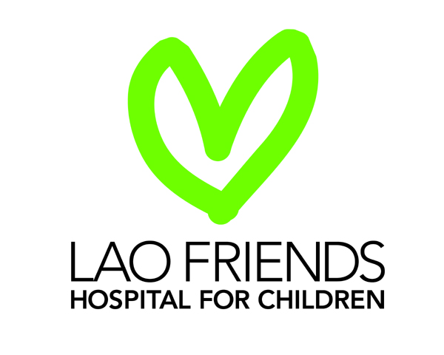
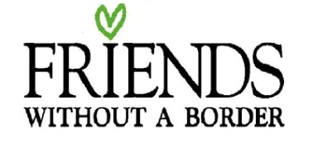

Position Available: Medical Director
Institution: Lao Friends Hospital for Children
Location: Luang Prabang, Lao PDR
Date posted: July 2021
Starting Date: As soon as possible
Duration: Two years

Lao Friends Hospital for Children (LFHC) is a 61-bed acute pediatric hospital situated in Luang Prabang, Lao PDR. It is operated by the New York based non-profit organization Friends Without A Border that is dedicated to providing high-quality and compassionate healthcare to the children in remote areas of Southeast Asia. In 2015 the hospital was opened on the same campus as the Luang Prabang Provincial Hospital and it has been developing its services since then.

LFHC is a teaching hospital offering emergency, inpatient, outpatient, and surgical services to babies and children throughout Northern Lao. Limited on-site radiology, laboratory, and pharmacy services, together with a homecare program complement these clinical activities. A major goal of this hospital is to promote the clinical learning and professional development of the local staff such that key positions within the hospital are progressively filled by a well-trained and dedicated local workforce.

Position Summary
The Medical Director of LFHC has primary responsibilities in three main areas. These are firstly maintaining and improving the quality of healthcare delivered within LFHC (in conjunction to other clinical executive member), secondly managing the allied health services, and thirdly managing the occupational health service.

Together with the other members of the LFHC Executive Team, the Medical Director will provide leadership and strategic direction to the hospital. They will be actively involved in the planning, development, and operationalization of new clinical services. They will work closely with the Medical Education Director and the Director of Nursing to ensure a coordinated approach to patient care and the delivery of high-quality medical education to all staff in accordance with the principles and values of LFHC.

In order to achieve this successfully the position requires a minimum two-year commitment.

Qualifications and Attributes:
Essential: 1) A Medical Degree from an internationally recognized university
2) Registration to practice clinical medicine in the applicant’s home country
3) 5 years experience in acute clinical medicine
4) A higher qualification in pediatrics and/or a pediatric subspecialty field

Highly desirable: 1) Additional training or experience in emergency medicine, neonatology, and/or tropical medicine
2) Experience in managing a hospital or hospital department
3) Experience working in a developing country
4) Commitment to providing compassionate and nurturing care to patients
5) A high degree of humility, patience, and cultural awareness
6) Demonstrated leadership, organizational, and teaching skills

Specific Duties Include:
- Providing close supervision and assistance with clinical care to Lao medical staff in the inpatient, outpatient, emergency, and neonatal units, including both day and night coverage. This includes providing approximately 1 week in 3 on-call backup for Lao and volunteer staff. Depending on the number of volunteer doctors at any given time, the position also includes a variable number of day and night shifts.
- Provide leadership for the hospital quality assurance program, initiating and supervise appropriate quality improvement activities including critical incident, morbidity and mortality reviews.
- Development of medical policies, procedures, and clinical practice guidelines as necessary.
- Recruitment, orientation, management, and performance review of volunteer medical personnel.
- Recruitment, management, and performance review and provide professional development to allied health personnel (radiology, pharmacy, nutrition, laboratory)
- Coordination of the occupational health program for all LFHC staff, including immunizations and testing as appropriate with referral to local Lao health resources when required.
- Development and improvement of the clinical aspects of the electronic medical record system.
- Close collaboration with the Executive Director and Medical Education Director on all aspects of clinical supervision, staff education, hospital leadership, and on-call duties.
- Providing a positive face and advocacy for the hospital with donors, potential donors, government officials, and others.

Salary and Benefits
Housing allowance; travel allowance; annual salary, health insurance

Application
Please email a cover letter, CV, and three references from past employers to hr@fwablaos.org.

Visit www.fwab.org/laos for further information.

For specific enquiries regarding this position, email to HR@fwablaos.org.

Only short-listed candidates will be contacted for interviewing.

